# Demo Deploying

## Install IIS Web Server

Windows itself comes with IIS, which is turned off by default by going to the "control panel >> program >> enable or disable Windows features" section

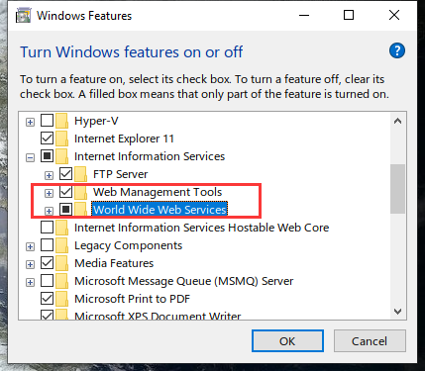

Once the IIS feature is turned on, you can enter "iis" in the start-up and program search box, find the iis application, and open it, and then you can configure iis to publish the asp.net website.

## 2.Add a site

Publish two sites under the folder to IIS.

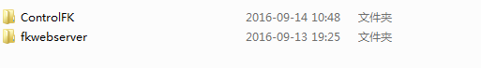

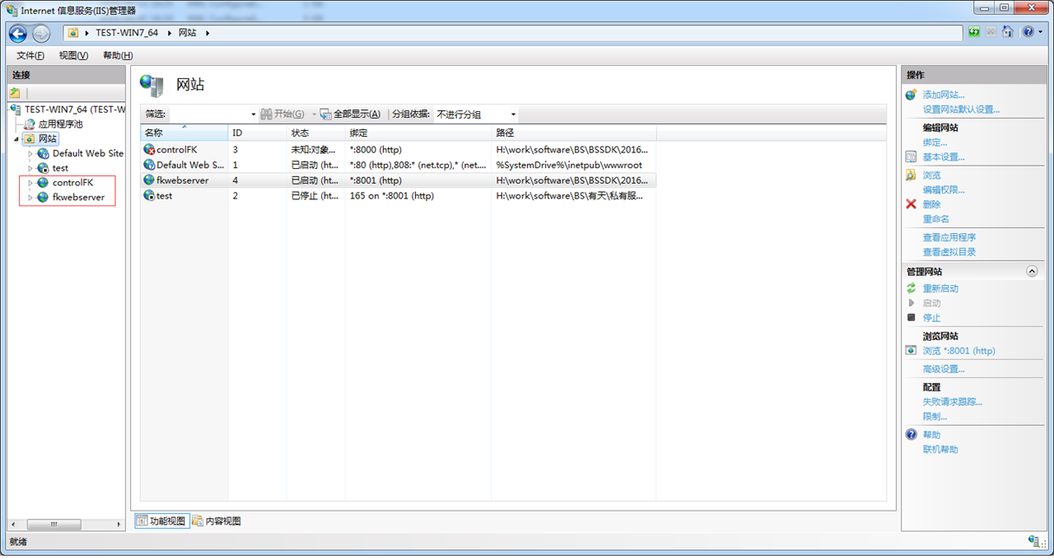

Step 1:Click"Website"right-click to add a website

­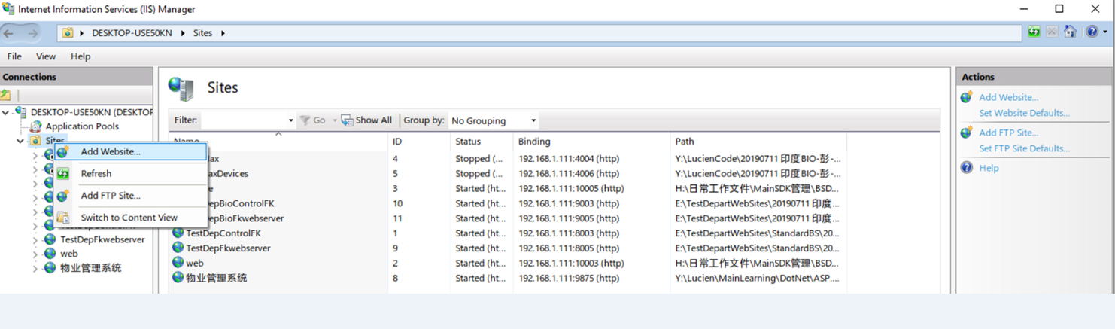

Step 2: Select the specified path for two site files, site name and port number can be assigned, other configuration default, no modification required

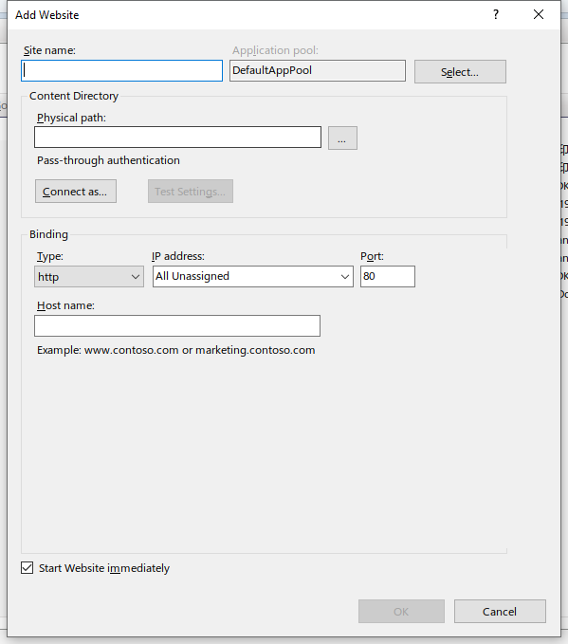

Step 3:Click OK to complete site publishing

Step 4:Build a database

The sample Demo recommends using SQLServer2005 or above database

Database script Sunder-essfolder, copied to the database to execute to generate the database table structure and stored procedures, after the build database is called AttDB



Step 5:Set up a web.configdatabase connection string for two sites

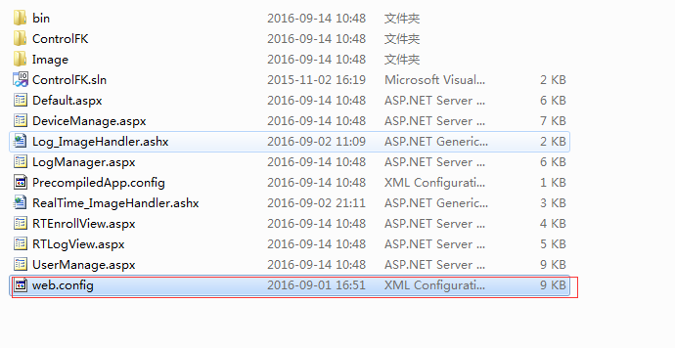

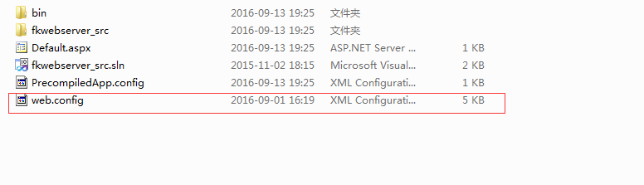

Adjust the database connection string shown in the figure below

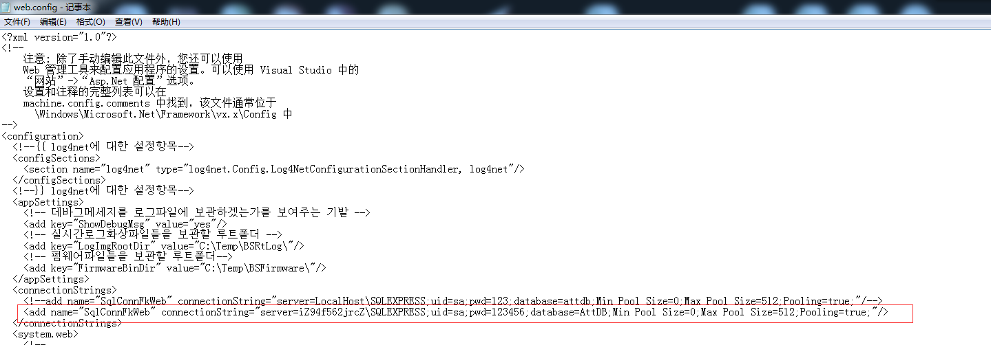

## 3. Frequently Asked Questions

### 3.1HTTP Error Status：500.19，500.21

1. Notice whether the permissions of the two sites are sufficient and require full control of the iIS-IUSRS, NETWORK-SERVICE two groups

2. Pay attention to whether the two sites of the application pool are started with .net framework 4.0

3. Be careful not to put two site files on the desktop

4. IF NEITHER OF THE ABOVE METHODS CAN NOT BE RESOLVED, IT IS .NET FRAMEWORK 4.0 WITHOUT REGISTRATION IIS USING CMD TO REGISTER C: S.WINDOWS.NET?FRAMEWORK?4.0.30319 ASPNET regiis.exe -i

5.C disk's Temp folder permissions are not enough, give the Temp folder a full control of the one one group full control permissions

6.fkwebserver needs to start with 32 bits, in the application, find the fkwebserver program pool, right-click select advanced settings, start the 32-bit application to True;

# Introduction and operation of Demo

Control site is responsible for user interaction

Fkwebserver site is responsible for machine interaction

This section of the section suggests and agreements for care and convenience

## Common instruction execution process

1. Machines are used at regular intervals (default6th0seconds, which can be set on the machine) will fkwebserver Site (to be set in communication settings on the machine) Request instruction (heartbeat pack)

2. When the user is in the control After the corresponding instruction is generated by the operation, control Insert instructions into the database There's a heartbeat pack coming up, fkwebserver The instructions are taken out of the database and returned to the machine and executed

3.The machine returns the execution result, fkwebserver Insert the results into the database

4.Control timely read from database Execution results

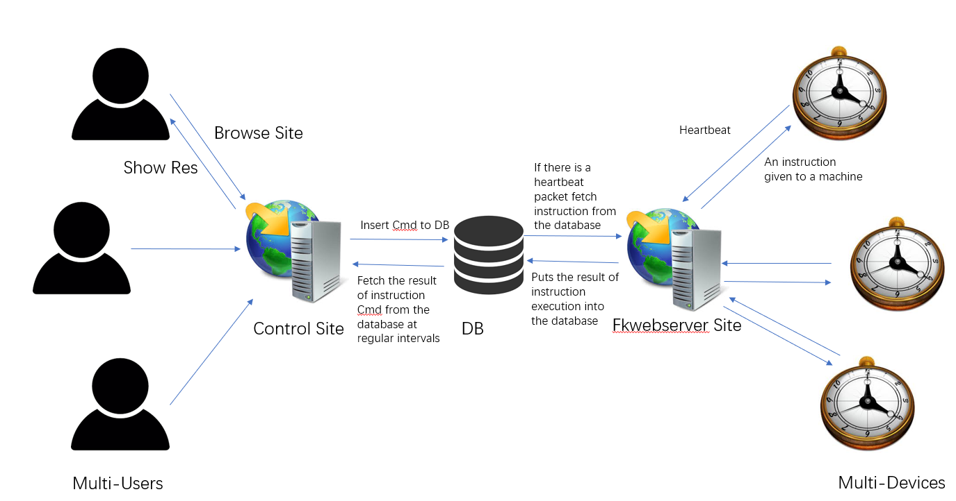

## Real-time data transfer process

When real-time data is generated, such as punching or registering fingerprint face data, the machine uploads records immediately, and the process is relatively simple.

1. Machine actively sends real-time data to fkwebserver
2. Fkwebserver returns to the machine that successfully received data and inserted it into the database
3. When a user visits a corresponding page in a Control site, such as Real-Time Log View, The page periodically takes data from the database and presents it to the user

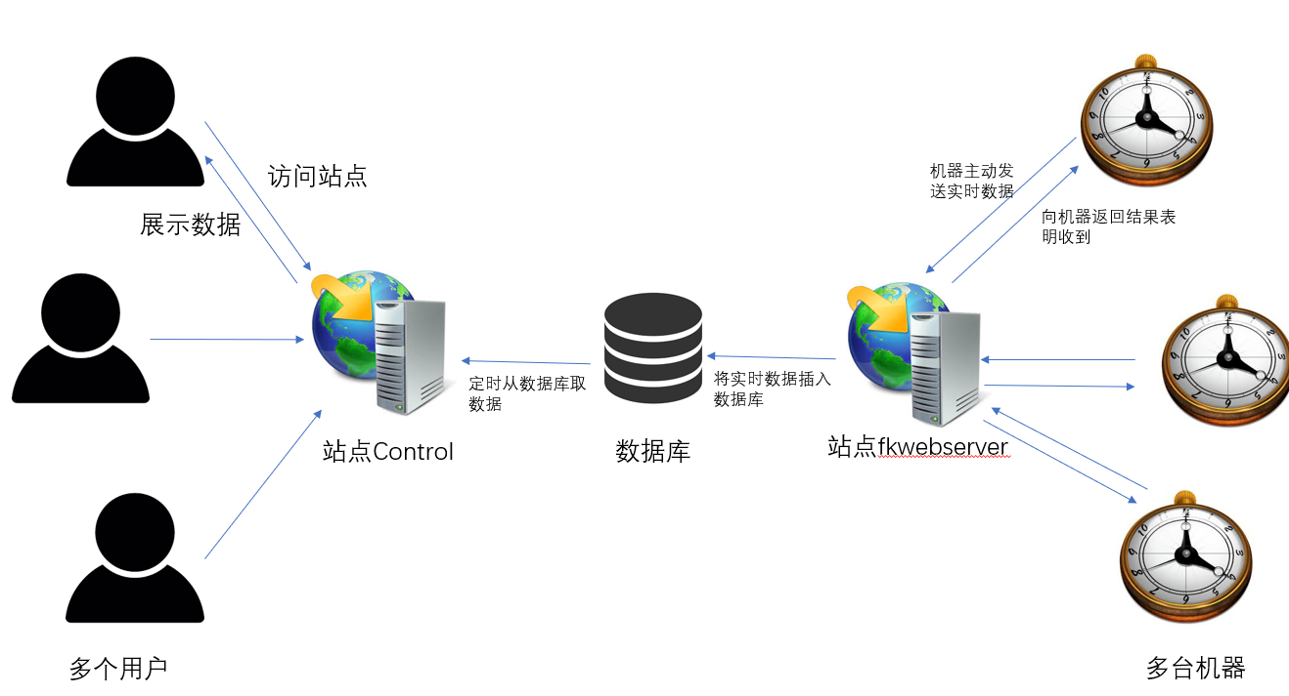

## Demo Operation

Devices: A list of machines connected to a site (in machine name), and when the icon on the machine home page has a "cloud", the corresponding machine name can be found in the list

Clear Devices: Non-instruction, clear the table in the database tbl? fkdevice-status, in order to clear too many unconnected machines in the list

Device Info: Content in it comes from the device's heartbeat pack

ID: Device cloud serial number

Name: Device Name

Firmware: Device firmware information

Support: device support edging method, the following image supports password, card, face, fingerprint

Info：

Fdata_ver:face data version

Fk_bin_data_lib: Parse bytes used by the class library, the source in fkwebserver, get attendance record (Get_Log_Data) is used

Fp_data_ver: Fingerprint data version

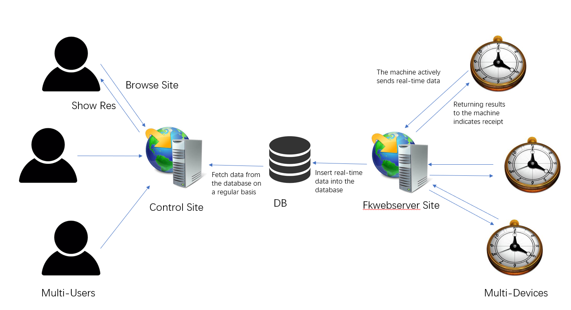

### User Management PersonNel Registration Information Management

1. Each entry automatically generates the instruction GET_USER_ID_LIST to get all the machine's job Numbers and update them to the User List

2. Get User Info can generate corresponding instructions to obtain the current device and User (ID) information：

To set up to another machine, click Modify User (no instructions) and select the machine in the Devices list in the upper right corner, and set user info(which generates corresponding instructions) is set to the corresponding machine

3.Other instructions With the agreement One-to-one correspondence

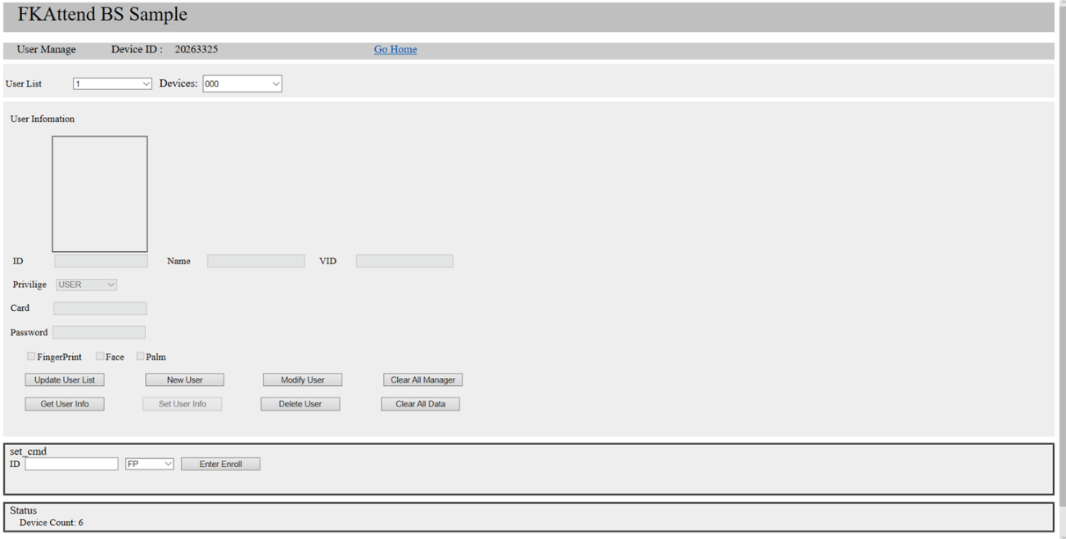

### Log Gets A Punch Ing-Out Record

1. When Data is empty, when the get log data instruction is executed, all records are taken from the machine
2. Data format is 2019/8/13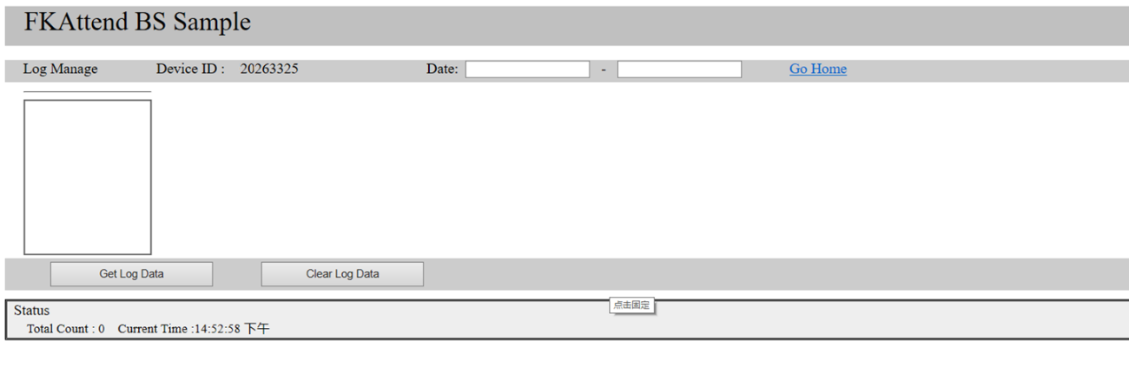

### Real-time data

Go to the corresponding page, clock in the machine or register the face, you can see the corresponding data